Sarı, S., et al., 2026, The world’s highest late Middle-Pleistocene marine deposits on the southern margin of the Central Anatolian Plateau (southern Türkiye): Geology, https://doi.org/10.1130/G55209.1.

Supplemental Material

Supplemental figures and tables include calcareous nannofossil, foraminiferal, and ostracod distribution data, oxygen isotope (δ¹⁸O) measurements, paleomagnetic analyses, and a compilation of the elevation and ages of MIS 7 marine deposits worldwide used for comparison in this study.

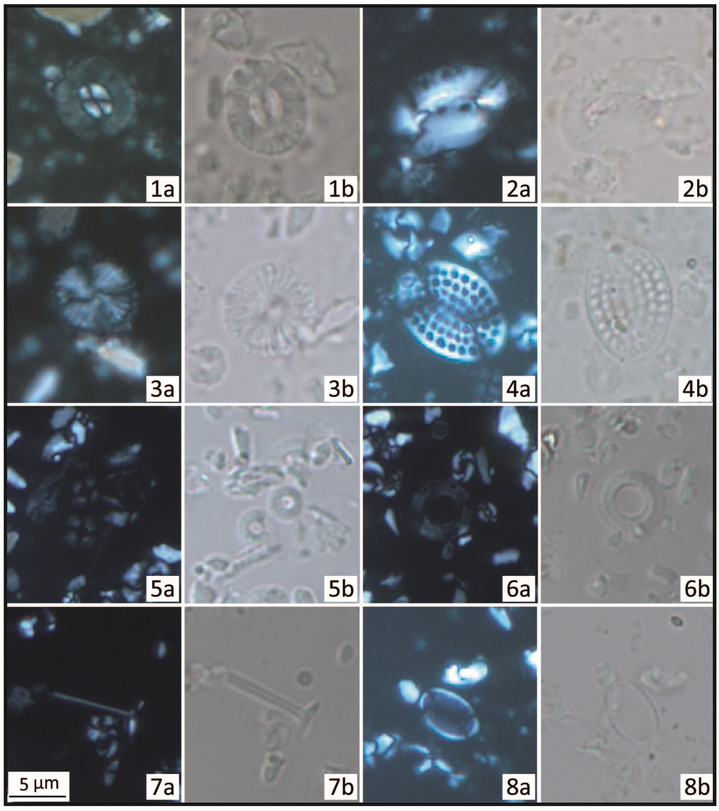
Figure S1. Microphotographs of calcareous nannofossils long-range taxa from the TOL-1 section. (1) Cocolithus pelagicus (TOL-1 5); (2) Helicosphaera carteri (TOL-1 2); (3) Calcidiscus. leptoporus (TOL-1 1); (4) Pontosphaera spp. (TOL-1 2); (5) Umbilicosphaera jafari (TOL-1 1); (6) Umbilicosphaera sibogae (TOL-1 1); (7) Rhabdosphaera clavigera (TOL-1 1); (8) Syracosphaera spp. (TOL-1 1). (a) Crossed nicols; (b) Parallel nicols. Scale bar uniform for all images.

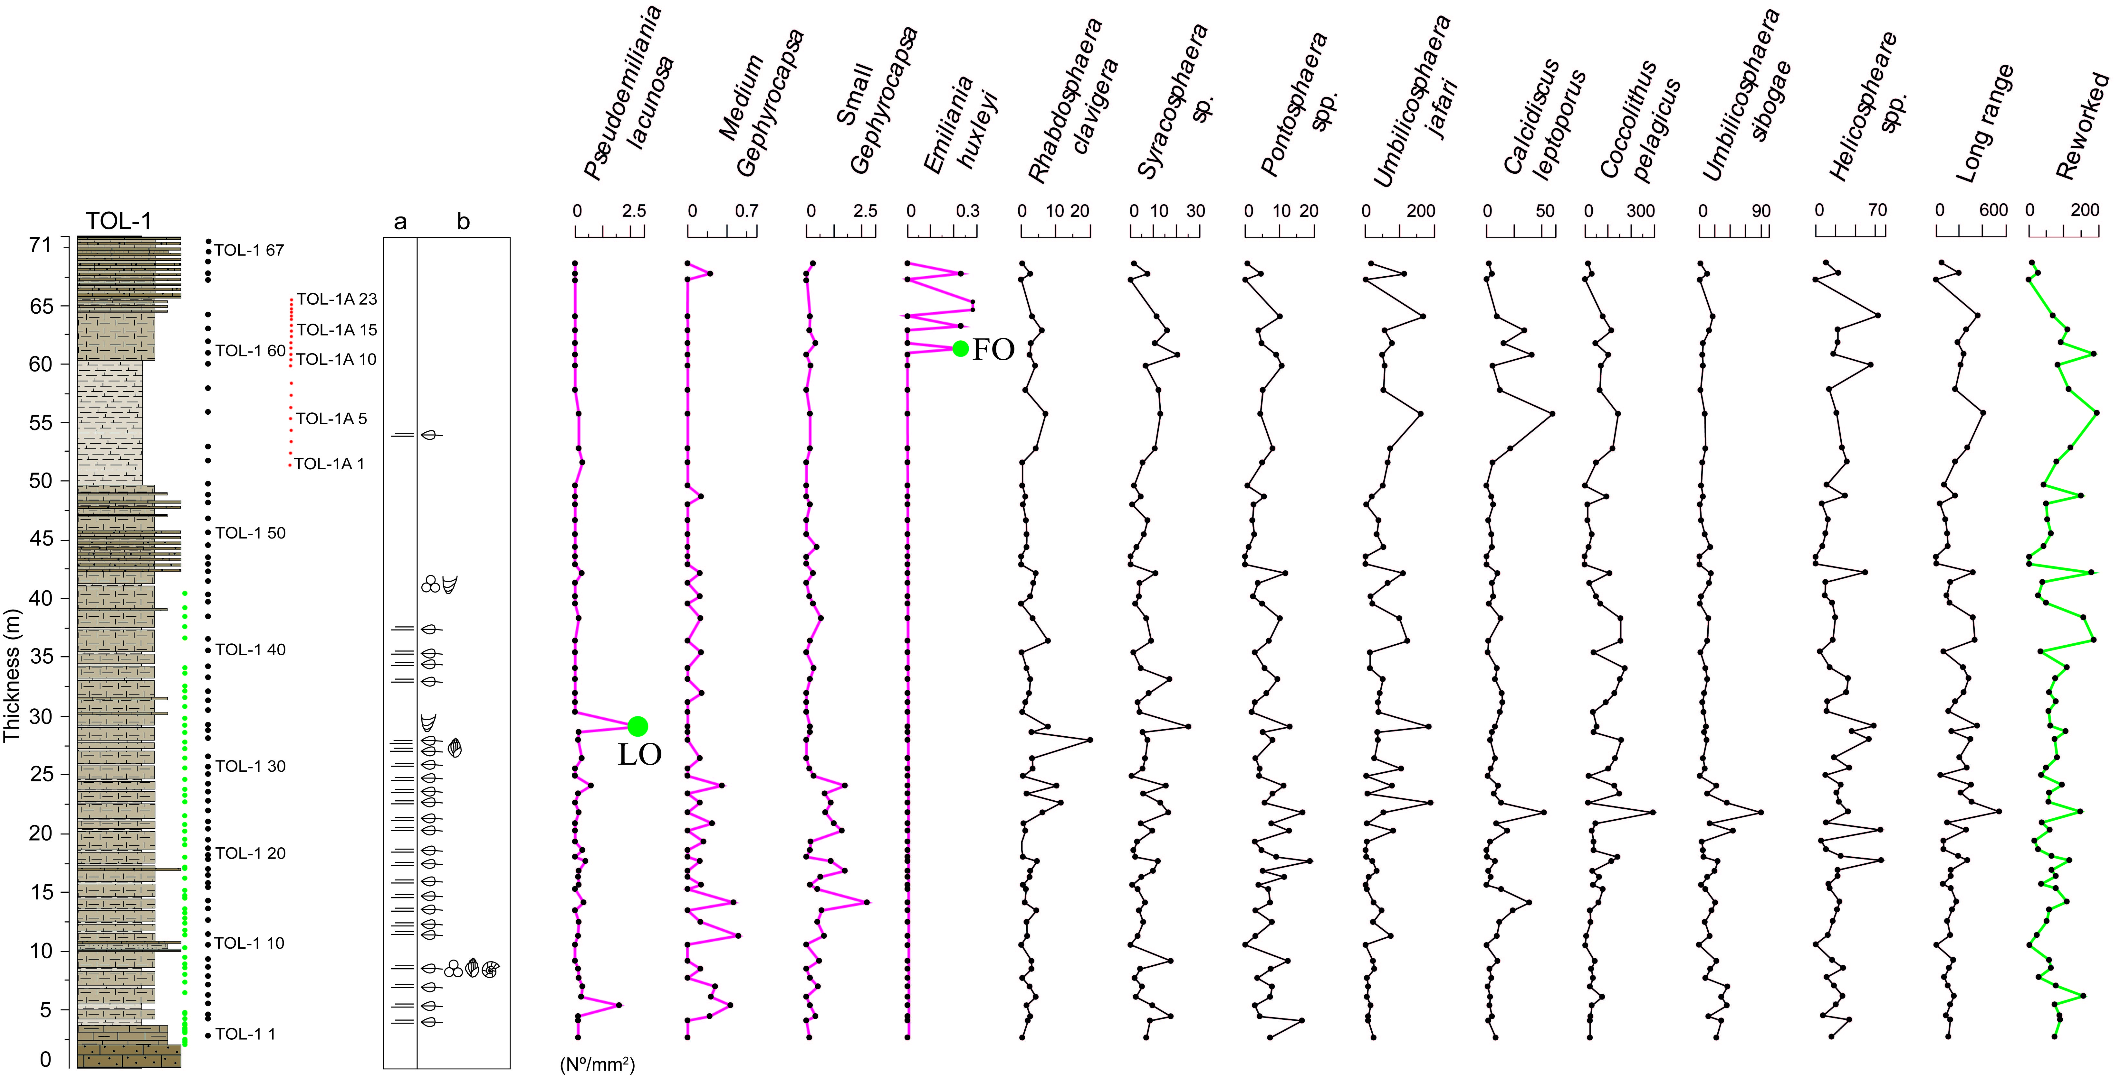
Figure S2. Calcareous nannofossil biostratigraphy of the TOL-1 section. Pink lines show index species, red circles mark concentrated samples, black lines indicate long-range species, and green lines show reworked species. Panels: (a) sedimentary structures; (b) fossil components.

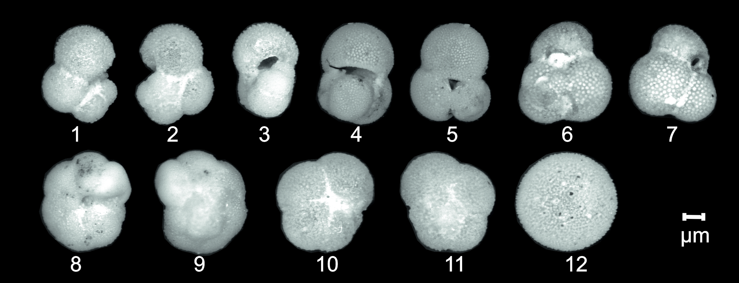

Figure S3. Scanning electron microscope (SEM) images of selected planktonic foraminiferal taxa from the TOL-1 section. (1) Globigerinella calida ventral view; (2) Globigerinella calida dorsal view; (3) Globigerinella calida axial view; (4) Globigerinoides quadrilobatus ventral view; (5) Globigerinoides quadrilobatus dorsal view; (6) Globigerinoides sacculifer ventral view; (7) Globigerinoides sacculifer dorsal view; (8) Neogloboquadrina dutertrei ventral view; (9) Neogloboquadrina dutertrei dorsal view; (10) Neogloboquadrina pachyderma ventral view; (11) Neogloboquadrina pachyderma dorsal view; (12) Orbulina universa.
Table S1. The semi-quantitative analysis on planktonic foraminifera was based on surveying a standard number of fields in the washing residue >125micron (according to Hilgen et al., 2003), distinguishing the following abundance categories: Present (P)<3 specimens, Rare (R) <3-10 specimens, Few (F) 10-30 specimens, Common (C) 30-50 specimens and Abundant (A) > 50 specimens. Preservation: low preservation (-); moderate preservation (+); good preservation (++). Indeterminate species are referred to incrusted and recrystallized species.

Sample ID | Thickness (cm) | Remarks on abundance | Preservation | Identerminate species | G. quadrilobatus | T. trilobus | G. glutinata | Orbulina universa | G.  calida | N. incompta | N. pachyderma | N. dutertrei | G. ruber (white) | G. bulloides | G. obliquus obliquus | G. rubescens | G. tenellus
TOL1-67 | 6995 | P | - | P | R | R | P |  |  |  |  |  |  |  |  | P
TOL1-66 | 6875 | P | - | P | P | P |  | R |  |  |  |  |  |  |  | P
TOL1-65 | 6785 | P | - | P | R | R |  | P |  |  |  |  |  | P |  | P
TOL1-64 | 6715 | F | + | C |  |  |  | F |  |  |  |  |  |  |  | P
TOL1-63 | 6420 | F | + | C | R | R | F | C | F | R |  |  | P |  |  | P
TOL1-62 | 6300 | C | + | C | C | C |  | C | P |  |  |  | P | P | R | R
TOL1-61 | 6190 | A | ++ | C | C | C |  | F |  |  |  |  |  | R | C | F
TOL1-60 | 6095 | A | ++ | F | D | D |  |  | F | R | R |  |  | P | C | F | F
TOL1-59 | 6000 | A | ++ | F | D | D | F | C | F | F | F |  |  | R | C | F
TOL1-58 | 5790 | A | + | C | D | D |  | C |  |  |  |  | R |  | C | F
TOL1-57 | 5590 | A | + | C | C | C | F | C |  |  |  |  |  |  | C | F
TOL1-56 | 5290 | A | + | C | D | D |  | C |  | P |  |  |  | P | F | R
TOL1-55 | 5170 | A | + | C | C | C |  | D |  |  |  |  |  | C | C | F
TOL1-54 | 4975 | A | + | C | C | C |  | C |  |  |  |  |  |  | C | F
TOL1-50 | 4555 | A | + | C | C | C |  | C |  |  |  |  |  |  | C | F
TOL1-49 | 4450 | A | + | C | C | C |  | C |  |  |  |  |  |  | F | R
TOL1-46 | 4225 | A | ++ | F | C | C |  | D |  |  |  |  |  | F | C | F
TOL1-41 | 3645 | A | ++ | F | D | D | F | C |  |  |  |  |  | F | C | F
TOL1-38 | 3320 | A | ++ | F | D | D |  | C | C |  |  |  |  | F
TOL1-35 | 3035 | A | ++ | F | D | D |  | F | C | R
TOL1-32 | 2800 | A | ++ | F | D | D |  | C | C |  |  |  |  |  | F | F
TOL1-27 | 2340 | A | ++ | F | D | D |  | C |  |  |  |  | C | F | F | F
TOL1-25 | 2180 | A | ++ | F | C | C |  | D |  |  |  |  |  | F | C | F
TOL1-23 | 2020 | A | ++ | F | C | C |  | D | F |  |  |  |  |  | C | F
TOL1-21 | 1855 | A | ++ | F | C | C |  | C |  |  |  | C |  |  | F | R
TOL1-19 | 1760 | A | ++ | F | C | C |  | D | R | R |  |  |  |  | C | F
TOL1-16 | 1560 | A | ++ | F | C | C |  | D | R | R |  |  |  |  | C | F
TOL1-13 | 1340 | C | ++ | F | C | C | R | D | R | R | R | F |  | R | F
TOL1-6 | 690 | C | + | A | C | C | R | D |  | P | P | F |  | R | F
TOL1-4 | 530 | C | + | C | C | C | R | D |  | P | P | F |  | R | F
TOL1-2 | 400 | A | ++ | C | C | C |  | F | R |  | R | F |  | F | F

Ostracods
Overall, the TOL-1 section yielded 107 taxa. Thirty-six species were considered reworked since their known stratigraphic distribution ended before Chibanian (Table S2). They are mainly shallow water species reworked from the Messinian marly limestones of the Mut Fm (i.e., Sarıalan and Başyayla sections – Babinot, 2002; Cosentino et al. 2012), from the Zanclean-Gelasian section of Kargıcak (Yıldız et al., 2003), and from the Calabrian section of Gülnar East (Öğretmen et al., 2018).
Twenty-two species were considered displaced, possibly from the nearby Tol section (Öğretmen et al., 2018) based on the population structure of each taxon, which, being unbalanced between adult and juvenile valves, are referable to transported death assemblages in high or low energy environments (Boomer et al., 2003). Among them, Bythocypris bosquetiana, Neglecandona sp., Cistacythereis emaciata, Cytherelloidea sp. Cyprideis sp. Kejiella sp. Macrocyprissa arcuata, Palmoconcha turbida and Sagmatocythere sp. are surely displaced being represented only by few juveniles.
Fourty-nine taxa (45 of which were identified at the species level) were considered autochthonous for their rather good preservation, the presence of carapaces and the balanced population age structures. Selected specimens are reported in Fig. S4.
On the autochthonous taxa, the unconstrained cluster analysis (Bray-Curtis similarity and the un-weighted pair group method using arithmetic average-UPGMA) in Q-mode was performed using the PAST software, ver. 4.06b (Hammer et al., 2001). Cluster analysis dendrogram, whose suitability was checked through the cophenetic correlation coefficient (c) (Sokal and Rohlf, 1962; Mouchet et al., 2008), has been used to determine sample groups based on their ostracod community composition. At a similarity level of 0.23, the obtained dendrogram reported in Fig. S7 (c=0.75) discriminates six clusters (Fig. S5).
Cluster 1 includes only sample TOL-1 63 characterised by the presence of the eurybathic species Argilloecia acuminata, accompanied by the infralittoral species Paracytheridea triquetra.
Cluster 2 groups samples TOL-1 2, TOL-1 6, TOL-1 10, TOL-1 14, TOL-1 35, TOL-1 41, TOL-1 42, TOL-1 45, TOL-1 46, TOL-1 51, TOL-1 53, TOL-1 55, TOL-1 56, TOL-1 57, and TOL-1 62, dominated by the eurybathic species Acanthocythereis hystrix and the littoral species Grinioneis haidingeri.
Cluster 3 gathers samples TOL-1 3, TOL-1 5, TOL-1 7, TOL-1 8, TOL-1 9, TOL-1 11, TOL-1 12, TOL-1 13, TOL-1 15, TOL-1 16, TOL-1 17, TOL-1 18, TOL-1 19, TOL-1 20, TOL-1 21, TOL-1 22, TOL-1 23, TOL-1 24, TOL-1 25, TOL-1 26, TOL-1 27, TOL-1 28, TOL-1 29, TOL-1 30, TOL-1 31, TOL-1 32, TOL-1 33, TOL-1 36, TOL-1 37, TOL-1 38, TOL-1 39, TOL-1 40, TOL-1 43, TOL-1 44, TOL-1 49, TOL-1-50, TOL-1-52, TOL-1-54, TOL-1 58, TOL-1 59, TOL-1 60, and TOL-1 61, characterised by the co-dominance of the epibathyal species Bythocypris producta, Cytherella robusta and Henryhowella sarsi profunda, occasionally accompanied by the eurybathic species Krithe iniqua.
Cluster 4 includes sample TOL-1 1, characterised by the dominant littoral species Aurila convexa accompanied by the eurybathc species Krithe iniqua.
Cluster 5 is made only by sample TOL-1 34 characterized by the only presence of the eurybathic species Acanthocythereis hystrix.
Finally, Cluster 6 includes only the topmost sample TOL-1 65 characterized by the presence of only the littoral species Hemicytherura defiorei.
The paleobathymetric reconstruction of the TOL-1 section has been proposed using the distribution of the samples in the dendrograms and considering the dominant species characteristic of each cluster and their autoecology (Table S3).
Table S2. List of the reworked ostracod species collected in the TOL-1 section.
Species | Stratigraphic range | Bathymetry | Literature
Aurila albicans (Ruggieri, 1958) | Middle Serravallian-  Early Messinian | 0-25 m | Bonaduce et al., 1992; Conesa and Babinot, 1999; Faranda et al., 2008; Ruggieri, 1958, 1962, 1967, 1976; Sissingh,1972.
Aurila calciplena (Uliczny, 1969) | Pliocene | littoral | Uliczny,1969; Mostafawi and Matzke-Karasz, 2006.
Aurila cicatricosa (Reuss, 1850) | Serravallian- Piacenzian | 0-25 m | Faranda et al., 2008.
Aurila freudenthali (Sissingh, 1972) | Middle Serravallian-  Early Messinian | 0-25 m | Aruta, 1983; Babinot and Boukli-Hacene, 1998; Bonaduce et al., 1987, 1992; Doruk,1973; Faranda et al. 2008; Miculan, 1992; Sissingh, 1972.
Aurila longa (Ruggieri,1962) | Tortonian- Early Messinian | 0-50 m (Porites) | Faranda et al., 2008.
Aurila punctata (Munster, 1830) | Langhian-Calabrian | 0-50 m | Ducasse and Cahuzac, 1996; Gross, 2006; Ruggieri, 1962, 1975;
Bairdoppilata profunda (Aiello, Barra and Bonaduce, 2000) | Langhian- Gelasian | 300-1000 m | Aiello and Barra, 2001; Aiello et al., 2000; Bonaduce and Barra 2002; Faranda et al.,  2007; Sciuto, 2003; Sciuto et al., 2003.
Buntonia dertonensis (Ruggieri, 1954) | Zanclean-Middle Gelasian | 50-1000 m | Aiello et al., 2000; Ciampo 1986.
Callistocythere montana (Doruk, 1980) | Serravallin-Early Messinian | 0-50 m | Doruk, 1980; Faranda et al., 2008
Callistocythere perfossa (Ciampo, 1984) | Tortonian -Early Messinian | 0-50 m | Ciampo, 1984.
Callistocythere sp. 1 (Babinot, 2002) | Messinian Inf | 0-50 m | Babinot, 2002.
Cardobairdia sp. 1 (Dall'Antonia, 2003) | Early Langhian-  EarlyTortonian | epibathial | Dall'Antonia, 2002, 2003.
Cimbaurila diecii (Sissigh,1972) | Late Serravallian-  Early Messinian | 0-25 m | Faranda et al., 2008
Cnestocythere lamellicosta (Triebel, 1950) | Langhian -Tortonian | 0-50 m | Aiello and Szczechura, 2004; Brestenska and Jiricek, 1978; Gross, 2006; Zorn, 2004
Costa (Cuneocosta) tricostata pliocenica (Ruggieri 1992) | Zanclean | 500 m | Ruggieri 1992
Cytherella cercinata (Aiello, Barra, Bonaduce and Russo, 1996) | Tortonian - Pliocene | 300-1000 m | Aiello et al., 1996; Doruk, 1974; Sissingh, 1972.
Cytherella russoi (Sissingh, 1972) | Langhian- Gelasian | 50-1000 m | Sissingh, 1972; Aiello et al., 2000; Bonaduce and Russo, 1985.
Eucytherura lamina (Ciampo, 1986) | Tortonian -Early Messinian | 50-500 | Ciampo, 1986.
Flexus triebeli (Ruggieri, 1962) | Zanclean - Calabrian | 5-40 m | Faranda et al., 2007
Graptocythere intricata (Terquem,1878) | Tortonian - Calabrian | 0-50 m | Faranda et al., 2007
Heliocythere vejhonensis (Procházka, 1893) | Langhian-Early Messinian | 0-25 m | Aiello and Szczechura, 2004; Bonaduce et al., 1998; Conesa and Babinot, 1999;  Faranda et al., 2008; Gross, 2006.
Loxoconcha punctatella; (Reuss, 1850) | Aquitanian–Early Messinian | 0-50 m (Porites ) | Aiello and Szczechura, 2004; Conesa and Babinot, 1999; Faranda et al., 2008;
Loxocorniculum quadricornis (Ruggieri, 1962) | Serravallian - Tortonian | 0-50 m | Babinot 2002; Conesa and Babinot, 1999; Dall'Antonia, 2002. Ruggieri, 1962.
Oblitacythereis mediterranea (Benson, 1977) | Zanclean | 250-1000 m | Aiello and Barra, 2001; Aiello et al., 2000; Barra et al., 1998; Bonaduce and Sprovieri,  1985; Violanti et al., 2009.
Occultocythereis bituberculata (Reuss, 1850) | Langhian –Early Messinian | 0-50 m | Aiello and Szczechura, 2004; Babinot 2002; Dall'Antonia and Bossio, 2001; Gross, 2006;
Orionina tegminata (Doruk, 1974) | Tortonian | 0-50 m | Babinot, 2002
Pachicaudites attenuatus (Ruggieri,1980) | Tortonian–Early Messinian | 0-50 m | Ciampo, 1986.
Paracytheridea inscita (Doruk, 1980) | Tortonian - Messinian inf. | 0-50 m | Doruk, 1980; El-Waer, 1988
Parakrithe ariminensis (Ruggieri, 1967) | Langhian. - Piacenzian | 100-1000 m | Aiello et al., 2000; Aiello and Barra, 2001; Bonaduce and Barra, 2002; Faranda et al.,  2007; Ruggieri, 1967;
Pokorniella devians (Bonaduce, Ruggieri and Russo, 1985) | Tortonian–Early Messinian | 0-50 m | Bonaduce and Russo, 1985; Faranda et al., 2008; Sissingh, 1972;
Pokorniella italica (Ruggieri, Russo and Bossio, 1977) | Tortonian–Early Messinian | 0-25 m | Aruta, 1983; Bonaduce et al., 1992; Conesa and Babinot, 1999; Faranda et al.,  2008; Miculan, 1992; Ruggieri et al., 1977; Sissingh, 1972;
Rethybythere (Bathybytere) vandenboldi, (Ruggieri,1960) | Gelasian-Calabrian | 500-1000 m | Aiello et al., 2000; Bonaduce et al., 2000; Colalongo, 1966; Colalongo and Pasini, 1980.
Ruggieria tetraptera (Seguenza, 1880) | Aquitanian - Pliocene | 0-1000 m | Aruta, 1983; Bonaduce and Barra, 2002; Bossio et al., 2006; Ciampo, 1980; Conesa and  Babinot, 1999; Miculan, 1992; Ruggieri, 1957.
Sagmatocythere cristatissima, (Ruggieri, 1967) | Tortonian–Early Messinian | 0-50 m (Porites) | Faranda et al., 2008
Sagmatocythere variesculpta (Ruggieri, 1962) | Tortonian - Messinian | littoral | Ruggieri, 1962; Miculan, 1992;
Sylvestra sp. (Mostafawi, 1990) | Tortonian -Early Messinian | 0-50 m | Mostafawi, 1990
Tenedocythere cruciata (Bonaduce, Ruggieri and Russo, 1986) | Serravallian-Early Messinian | 0-25 m | Bonaduce et al., 1984; Faranda et al., 2008; Mostafawi, 2002.
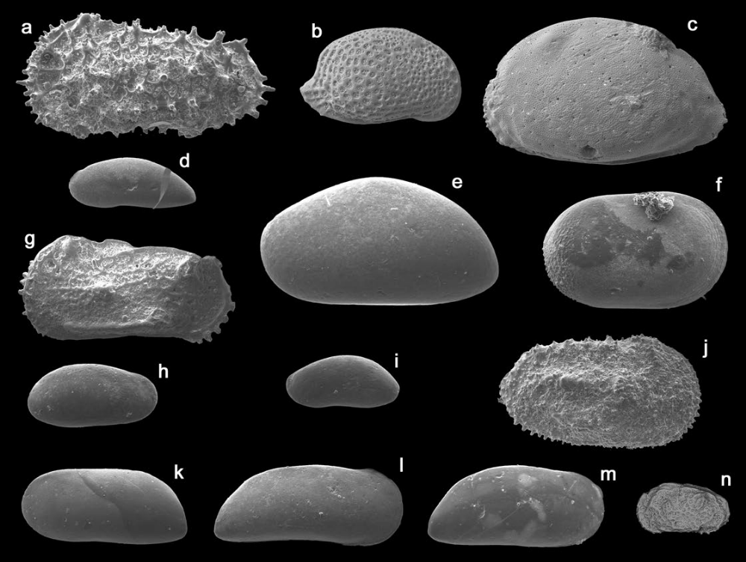
Figure S4. SEM images of selected ostracod species—(a) Acanthocythereis hystrix, VS, TOL-1 6. (b) Aurila convexa, VD, TOL-1 13. (c) Aurila neviani, VS, TOL-1 51. (d) Argilloecia acuminata, VS, TOL-113. (e) Bythocypris producta, VS, TOL-1 15. (f) Cytherella robusta, VD, TOL-1 12. (g) Grinioneis haidingeri, VS, TOL-1 3. (h) Parakrithe rotundata, VD, TOL-1 33. (i) Argilloecia fatua, VS, TOL-1 40. (j) Henryhowella sarsi profunda, VD, TOL-1 15. (k) Krithe iniqua, VS, TOL-1 15. (l) Krithe perpulchra, VD, TOL-1 3. (m) Krithe compressa, VD, TOL-1 15. (n) Callistocythere cf. rastrifera, VS, TOL-1 64. VD, valve in dorsal view; VS, valve in side (lateral) view. Scale bar: 0.1 mm.
Table S3. Autecological characteristics of the autochthonous ostracod species.
Species | Stratigraphic range | Bathymetry | Literature
Acanthocythereis hystrix (Reuss, 1850) | Langhian- Recent | 50-1000 m | Aruta, 1983; Babinot and Boukli-Hacene, 1998; Bonaduce and Barra, 2002; Bonaduce et al., 1976; Dall'Antonia and Bossio, 2001; Faranda and Gliozzi, 2008; Miculan, 1992.
Argilloecia acuminata (Müller, 1894) | Serravallian - Recent | 50-2500 m | Aiello et al., 2000; Aiello and Barra, 2001; Barra et al., 1996; Colalongo et al., 1981; Malz and Jellinek, 1984; Sciuto and Rosso, 2008
Argilloecia fatua (Barra, Aiello and Bonaduce, 1996) | Serravallian - Cal. (Sic.) | 50-1000 m | Aiello et al., 2000; Aiello and Barra, 2001; Aiello et al., 2015; Ciampo, 1986.
Argilloecia micra (Bonaduce, Ciampo and Masoli, 1976) | Pliocene - Rec | 170-1000 m | Barra et al., 1996; Bonaduce et al., 1976;
Aurila convexa (Baird, 1850) | Tortonian - Recent | 0-122 m | Aiello et al., 2015; Barra, 1997; Breman, 1976; Bonaduce et al., 1976; Conesa and Babinot, 1999; Lachenal, 1989; Mostafawi, 1990; Nachite et al., 1993; Ruggieri, 1975, 1983; Zagger and Malz, 1989;
Aurila nevianii (Ruggieri, 1953) | Gelasian - Recent | 0-50 m | Aranki et al., 1992; Ruggeri, 1953, 1959, 1962, 1980.
Bairdoppilata conformis (Terquem, 1878) | Gelasian (MPl5b) - Recent | 70-200(1000) m | Aiello et al., 2000; Aruta, 1983; Bonaduce and Barra, 2002; Conesa and Babinot, 1999; Colalongo  1966; Colalongo e Pasini 1980; Ruggieri,1962; Terquem, 1878.
Basslerites berchoni (Brady, 1870) | Zanclean - Recent | 0-50 m | Lachenal, 1989; Faranda and Gliozzi, 2008
Bythocypris bosquetiana (Brady, 1866) | Zanclean - Recent | 500-1000 m | Aiello et al., 2000; Breman, 1975; Colalongo and Pasini, 1980.
Bythocypris producta (Seguenza, 1880) | Langhian- Chiban | 500-1000 m | Aiello and Barra, 2001; Aiello et al., 2000; Bonaduce and Barra 2002; Colalongo et al., 1981; this  paper
Callistocythere rastrifera (Ruggieri, 1953) | Piacenz. - Recent | inner infralittoral | Mostafawi, 1981; Ruiz et al., 1997.
Carinocythereis carinata (Roemer, 1838) | Langhian- Recent | 0-104 m | Faranda and Gliozzi, 2008; Lachenal, 1989
Caudites calceolatus (Costa, 1853) | Tortonian - Recent | 0-1 m | Arbulla et al., 2004; Lachenal, 1989
Celtia biflexia (Terquem,1878) | Pliocene - Recent | 0-50 m | Terquem, 1878; Wood, 2005
Celtia quadridentata (Baird,1850) | Zanclean(Mpl1) –  Calabrian (Sant.) | 0-50 m | Faranda and.Gliozzi, 2008; Wood, 2005
Cistacythereis emaciata (Brady, 1867) | Pliocene - Recent | 50-100 m | Yassini, 1979; Wood, 2005.
Cistacythereis rubra (Müller,1894) | Tortonian - Recent | 0-18 m | Arbulla et al., 2004; Lachenal, 1989
Costa edwarsii (Roemer,1838) | Langhian- Recent | 13-120 m (40-60 FF) | Arbulla et al., 2004; Lachenal, 1989
Cytherella robusta (Colalongo and Pasini, 1980) | Langhian- Late Pleist. | 300-1000 m | Aiello and Barra, 2001; Bonaduce and Barra 2002; Bonaduce and Sprovieri, 1985; Colalongo et al.,  1981, 1990; Faranda et al., 2007. Pirkenseer et al., 2018.
Cytheretta subradiosa (Roemer, 1838) | Zanclean(MPl2) - Recent | 0-60 m | Faranda and Gliozzi, 2008; Malz and Jellinek, 1984; Montenegro et al, 1998; Lachenal, 1989;  Yassini, 1979;
Echinocythereis (Rhodicythereis) pustulata (Namias, 1900) | Zanclean(MPl1)- Calabrian(Sic) | 30-40 m | Faranda and Gliozzi, 2008
Eucytherura angulata (Müller, 1894) | Tortonian - Recent | 0-50 m | Aruta, 1983; Bonaduce et al., 1976; Ciampo, 1986; Miculan, 1992; Müller, 1894; Ruggieri,1976.
Grinioneis haidingeri (Reuss, 1850) | Burdigalain - Chibanian | 0-100 m | Aiello and Szczechura, 2004; Aranki et al., 1992; Brestenska and Jiricek, 1978; Conesa and Babinot, 1999;  Faranda and Gliozzi, 2008; Faranda et al., 2007; Ruggieri, 1953, 1962, 1976; Sissingh, 1972, 1973; this paper.
Hemicytherura defiorei (Ruggieri 1953) | Serravallian- Recent | 0-100 m | Aiello and Szczechura, 2004; Brestenska and Jiricek, 1978; Aiello et al., 2015; Faranda et al., 2008;  Lachenal, 1989
Henryhowella sarsii profunda (Bonaduce, Barra and Aiello, 1999) | Aquitanian - Recent | 110-1000 m | Aiello and Barra, 2001; Aiello et al., 2000; Aiello et ali. 2015; Bonaduce and Barra, 2002; Bonaduce and  Sprovieri, 1985; Faranda et al., 2007; Sciuto, 2003; Sciuto and Rosso, 2008; Sciuto et al., 2003;
Heterocythereis albomaculata (Baird,1850) | Piacenzian - Recent | 10-70 m | Athersuch et al., 1989; Bassiouni, 1979; Faranda and Gliozzi 2008; Guillaume et al.,1985; Sciuto,  2003; Yassini, 1979;
Krithe compressa (Seguenza, 1880) | Zanclean-Late Pleistocene | 160-1000 m | Aiello et al., 2000; Aiello et al., 2015; Bassetti et al., 2010; Barra et al., 1998; Ciampo, 1986;  Ruggieri, 1991; Sciuto and Rosso, 2008;
Krithe iniqua (Abate, Barra, Aiello and Bonaduce, 1993) | Langhian- Chibanian | 50-1000 m | Aiello et al., 2000; Aiello and Barra, 2001; Bonaduce and Barra, 2002; Ciampo, 1986;  Sciuto and Rosso, 2008; this paper
Krithe pernoides (Bornemann, 1855) | Tortonian - Late Pleistocene | 50-1000 m | Aiello et al., 1993; Aiello et al., 2000; Bassetti et al., 2010; Ciampo 1986;
Krithe perpulchra (Abate, Barra, Aiello and Bonaduce, 1993) | Piacenzian (MPl5a)-  Chibanian | 1000 m | Abate, et al., 1993; Aiello et al., 2000; this paper
Loxoconcha ovulata (Costa, 1853) | Late Tortonian- Recent | 2-55 m | Arbulla et al., 2001, 2004; Babinot and Boukli-Hacene, 1998; Faranda and Gliozzi,  2008; Lachenal, 1989
Macrocyprissa arcuata (Colalongo e Pasini,1980) | Calabarian- Recent | 500- 1500 m | Colalongo and Pasini, 1980; Coles et al., 1996; Maddocks 1979, 1990;
Microxestoleberis xenomis (Barbeito-Gonzales, 1971) | Recent | 50-110 m | Bonaduce et al., 1988
Monoceratina mediterranea (Sissingh, 1972) | Tortonian - Recent | circalitorale (>160 m) | Bonaduce et al., 1976; Ertekin and Tonoğlu, 2008
Paracytheridea depressa depressa (Müller, 1894) | Pliocene- Recent | 10-120 m | Bonaduce et al., 1976; Ciampo, 1976; Danatsas, 1994; Müller, 1894; Yassini, 1979;  Zangger and Malz, 1989.
Paracytheridea triquetra (Reuss, 1850) | Aquitanian- Recent | 8-26 m | Aiello and Szczechura, 2004; Babinot, 2002; Babinot and Boukli-Hacene, 1998;  Faranda and Gliozzi, 2008; Mostafawi, 1989; Ruggieri, 1962;
Palmoconca turbida (Müller, 1894) | Zanclean - Recent | 20-210 m | Bonaduce et al., 1976; Lachenal, 1989; Yassini, 1980.
Parahemingwayella tetrapteron (Bonaduce, Ciampo and Masoli, 1976) | Late Tortonian- Recent | 120-1000 m | Aiello et al., 2000; Bonaduce et al., 1976.
Parakrithe ambigua (Ciampo, 1980) | Piacenzian(MPl4)- Recent | 1000 m | Aiello et al., 1993; Ciampo, 1980.
Parakrithe rotundata (Aiello, Barra, Abate and Bonaduce, 1993) | Langhian- Chibanian | 500-1000 m | Aiello et al., 1993; Aiello et al., 2000; Bonaduce and Barra, 2002; this paper.
Parakrtithe dimorpha (Bonaduce, Ciampo and Masoli, 1976) | Late Langhian - Recent | 70-1000 m | Aiello et al., 1993; Bonaduce et al., 1976; Faranda and Gliozzi, 2008;
Pseudopsammocythere reniformis (Brady, 1868) | Late Pleistocene- Recent | 0-25 m | Bonaduce et al., 1988; Zagger and Malz, 1989.
Xestoleberis communis (Müller, 1894) | Early Messinian-Recent | 0-100 m | Babinot and Boukli-Hacene, 1998; Faranda and Gliozzi, 2008; Lachenal, 1989.
Xestoleberis dispar (Müller, 1894) | Zanclean - Recent | 0-40 m | Aiello et al., 2020, 2021; Arbulla et al., 2004; Faranda and Gliozzi, 2008.

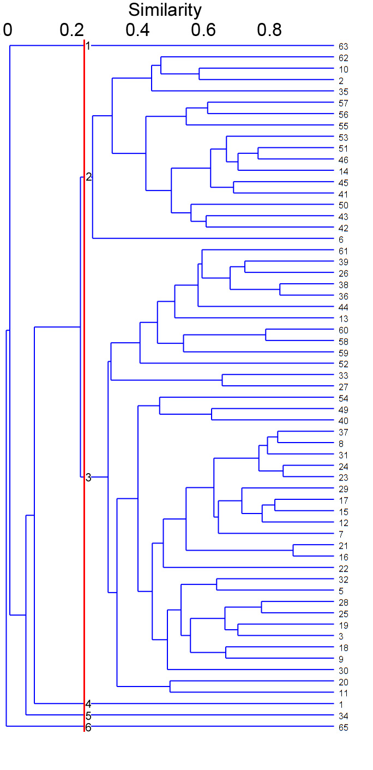
Figure S5. Dendrogram of the Cluster Analysis of ostracod assemblages in Q-mode applied on the samples of TOL-1 section.

Table S4. Stable oxygen-isotope (δ¹⁸O) stratigraphy of the TOL-1 section.
Thickness (cm) | δ¹⁸O‰ (PDB)
5170 | -0.60
4140 | -0.52
3035 | -1.25
2865 | -0.62
2800 | -1.10
2640 | -0.69
2490 | -1.19
2260 | -0.90
1800 | -0.25
1760 | -0.53
1625 | -1.27
1520 | -0.87
1240 | -0.61
760 | -0.26
690 | -0.43
600 | -0.59
400 | -2.20

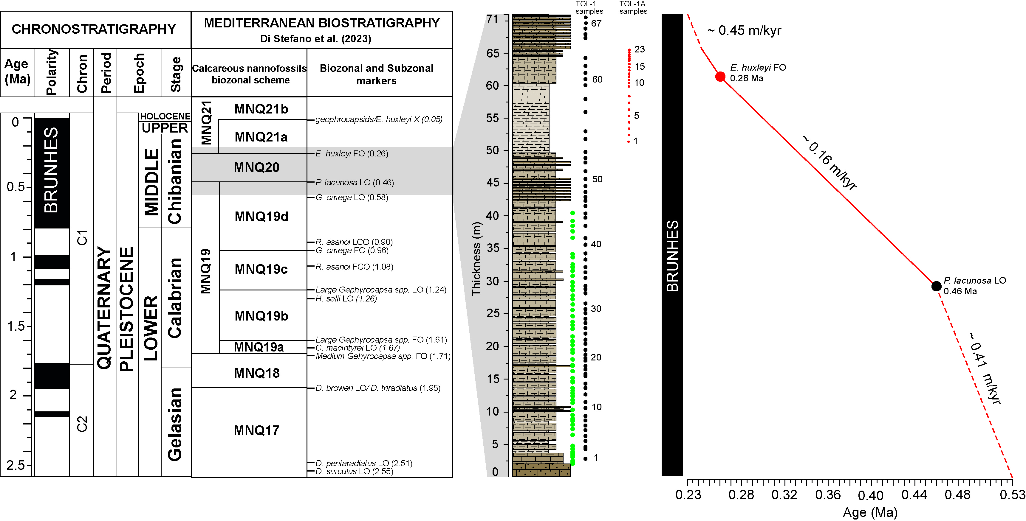
Figure S6. Integrated Mediterranean biostratigraphic scheme for the Pleistocene (Di Stefano et al., 2023), which includes astronomically calibrated magnetic reversal records. Key biostratigraphic markers include first common occurrences (FCO) and last common occurrences (LCO). The grey strip indicates the proposed age for the TOL-1 section. To the right, age constraints and sedimentation rates of the TOL-1 section as evidenced in this work.
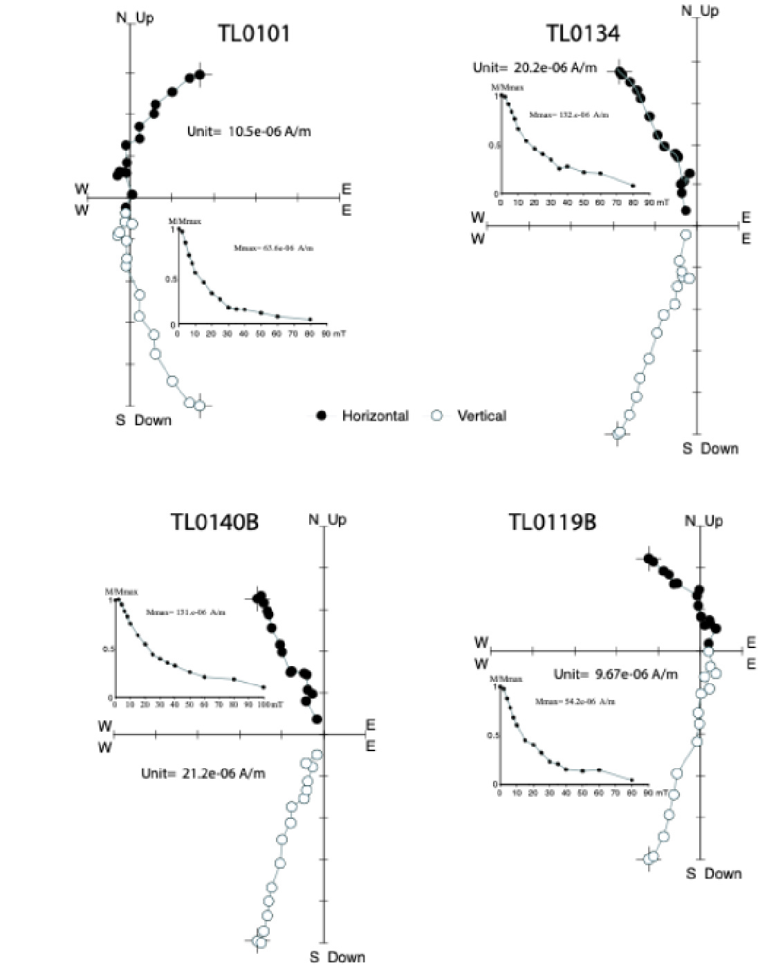
Figure S7. Orthogonal vector diagrams for the progressive alternating field (AF) demagnetization of representative samples. Open and solid symbols represent projections on the vertical and horizontal planes, respectively. N/UP, W, E, and S/DOWN indicate horizontal (north, south, west, and east) and vertical (up and down) projections combined into a single vector component diagram. For each sample, progressive AF demagnetization data in mT are reported.

Table S5. Global compilation of Marine Isotope Stage (MIS) 7 records from around the world, showing deposits at different elevations, dating methods, and tectonic contexts. Abbreviations: MIS = Marine Isotope Stage; OSL = Optically Stimulated Luminescence; U-Th = Uranium-Thorium dating; AAR = Amino Acid Racemization; ESR = Electron Spin Resonance; TL = Thermoluminescence; IRSL = Infrared Stimulated Luminescence; bsf = below sea floor; TR = Turkey; TN = Tunisia; IT = Italy; GB = Great Britain; ROK = Republic of Korea; BRA = Brazil; USA, HI = United States of America, Hawaii; UP = Upper plate; LP = Lower plate
Locality | MIS | Method for dating | Elevation (m) | Tectonic context | Reference
CAP N-margin (TR) | 7 | inferred | 58 | Passive margin | Berndt et al. (2018)
Hampshire (UK) | 7b-7c | OSL | 10 | Passive margin | Bates et al. (2010)
Cap Bon (TN) | 7 | inferred | 15 | Passive margin | Elmejdoub and Jedoui (2009)
South Carolina (USA) | 7 | U-Th, OSL | 10.7 | Passive margin | Sanders et al. (2009); Doar III and Kendall (2017)
Argentarola Cave (IT) | 7 | U-Th | -9/-18 | Passive margin | Bard et al. (2002)
Morston (GB) | 7/6 | OSL | 5 | Passive margin | Hoare et al. (2009)
Central East Coast of South Korea (ROK) | 7 | Cosmogenic ¹⁰Be | 60–80 | Passive margin | Lee et al. (2015); Hong et al 2024
Central East Coast of South Korea (ROK) | 7 | OSL | 40 | Passive margin | Ko et al. (2009)
Central East Coast of South Korea (ROK) | 7 | OSL | 32-55 | Passive margin | Kim et al. (2007)
Rio Grande do Sul (BRA) | 7e | TL + ESR | 10 | Passive margin | Lopes et al. (2014)
Bahamas | 7c, 7e | U-Th | -10 to -15 | Passive margin | Li et al. (1989)
Bahamas, Bermuda | 7a, 7e | U-Th, AAR | 2.5 to 0 | Passive margin | Hearty and Kindler (1995)
Australia | 7a-c | TL | 4-2 | Passive margin | Roy et al. (1997)
Spain | 7e | U-Th | 5 | Passive margin | Vesica et al. (2000)
NE Brazil | 7c | TL, OSL | 5-3 | Passive margin | Barreto et al. (2002)
Bahamas | 7a-e | U-Th | 12-20 m bsf | Passive margin | Robinson et al. (2002)
Australia | 7a | TL, AAR | 8 | Passive margin | Murray-Wallace (2002)
Alicante, Spain | 7e | U-Th | 4.5-1.5 | Passive margin | Goy et al. (2006)
Argentarola Cave, Italy | 7a, 7c, 7e | U-Th | -18/-21 | Passive margin | Dutton et al. (2009)
NE Brazil | 7c | OSL, TL | >4 to >1.7 | Passive margin | Suguio et al. (2011)
Patagonia | 7 | inferred | 35-26 | Passive margin | Pedoja et al. (2011)
Patagonia Pto Piramide | 7 | inferred | 29 | Passive margin | Schellmann and Radtke (2000)
Patagonia Caleta Valdez | 7 | U-Th | 32 | Passive margin | Codignotto et al. (1992)
Patagonia Bahia Camarones | 7 | U-Th, Paleontology | 24.5 | Passive margin | Rostami et al. (2000)
Patagonia Bahia Bustamente | 7 | ESR, U-Th | 26 | Passive margin | Rostami et al. (2000)
Patagonia Caleta Olivia | 7 | ESR, U-Th | 32 | Passive margin | Codignotto et al. (1992)
South China Sea | 7 | inferred | 40-22 | Passive margin | Pedoja et al. (2008)
Bermuda | 7e | U-Th | 6-4.5 | Passive margin | Rowe et al. (2014)
Oahu (USA, HI) | 7 | U-Th | -10/-20 | Volcanic Arc | Sherman et al. (1999); Mush and Szabo (1994)
Muroto Peninsula Japan | 7 | Tephrochronology | 260 | Island Arc UP | Matsu’ura (2015)
Sumba Island, Indonesia | 7e | ESR, U-Th | 51 | Island Arc Subduction UP | Pirazzoli et al. (1991)
Barbados | 7a, 7e | U-Th | 78-92 | Island Arc Subduction UP | Gallup et al. (1994)
Kendal Hill, Aberdare, Barbados | 7a, 7c | ESR, U-Th | 52-47  70-65 | Island Arc Subduction UP | Schellmann et al. (2004)
Kish Island Persian Gulf | 7 | U-Th, ESR | 1.5-6 | Subduction LP | Pirazzoli et al. (2004)
Kish Island Persian Gulf | 7 | ESR | 25.5-28 | Subduction LP | Pirazzoli et al. (2004)
Taranto (IT) | 7e | AAR | 73 | Subduction LP | De Santis et al. (2018)
Pan de Azucar, Chile | 7 | Cosmogenic ¹⁰Be | 64 | Subduction UP | Martinod et al. (2016)
Calabrian Arc (IT) | 7-9? | AAR + IRSL | 225 | Subduction UP | Belluomini et al. (1988); Nalin et al. (2020)
Bahia Iglesa, Chile | 7 | ESR | 78 | Subduction UP | Radtke (2020?)
Caleta Chanaral, Chile | 7 | Cosmogenic ¹⁰Be | 54 | Subduction UP | Martinod et al. (2016)
Altos de Talinay, Chile | 7 | Cosmogenic ¹⁰Be | 55 | Subduction UP | Saillard et al. (2009)
Caldera, Chile | 7 | inferred | 44 | Subduction UP | Marquardt et al. (2004)
Bahia Iglesa, Chile | 7 | inferred | 40 | Subduction UP | Marquardt et al. (2004)
Hornitos, Chile | 7 | AAR | 60 | Subduction UP | Ortlieb et al. (1996)
Kamikita Plain, NE Honshu (Japan) | 7c-7e | Tephra and phytolith stratigraphy | 50 | Subduction UP | Matsu’ura et al. (2019)
Makran Coast (SE Iran and SW Pakistan) | 7 | Stratigraphy, terrace morphology | 41–72 | Subduction UP | Normand et al., 2019
Altos de Talinay, Chile | 7 | Cosmogenic ¹⁰Be | 30 | Subduction UP | Martinod et al. (2016)
W and SE Cyprus | 7 | U-Th | 8-11 | Subduction UP | Poole et al., 1990
NE Cyprus | 7 | U-Th | 40 | Subduction UP | Palamakumbura et al., 2016

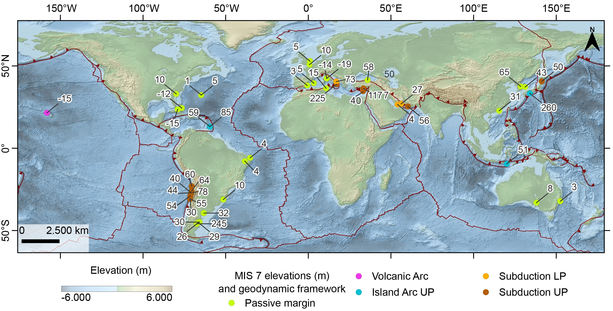
Figure S8. Global distribution of MIS 7 marine record, highlighting their varying elevations across different tectonic contexts (data set in Table S5).

REFERENCES
Abate, S., Barra, D., Aiello, G., and Bonaduce, G., 1993, The genus Krithe Brady, Crosskey and Robertson, 1874 (Crustacea: Ostracoda) in the Pliocene-Early Pleistocene of the M. San Nicola Section (Gela, Sicily): Bollettino della Società Paleontologica Italiana, v. 32(3), p. 349-366.
Aiello G., Barra D. & Bonaduce G., 1996, The genus Cytheropteron Sars 1866 (Crustacea: Ostracoda) in the Pliocene-Early Pleistocene of the M. San Nicola Section (Gela, Sicily): Micropaleontology, v. 42 (2), p.167-178.
Aiello, G. and Szczechura, D., 2004, Middle Miocene ostracods of the Fore-Carpathian Depression (Central Paratethys, southwestern Poland): Bollettino della Società Paleontologica Italiana, v. 43(1-2), p. 11-70.
Aiello, G., Amato, V., Barra, D., Caporaso, L., Caruso, T., Giaccio, B., Parisi, R., and Rossi, A., 2020, Late Quaternary benthic foraminiferal and ostracod response to palaeoenvironmental changes in a Mediterranean coastal area, Port of Salerno, Tyrrhenian Sea: Regional Studies in Marine Science, v. 40, p. 101498.
Aiello, G., and Barra, D., 2001, Pliocene ostracod assemblage in the Capo Rossello borehole (Agrigento, Sicily): Bollettino della Società Paleontologica Italiana, v. 40(1), p. 97-103.
Aiello, G., Barra, D., Abate, S., and Bonaduce, G., 1993, The genus Parakrithe van den Bold, 1958 (Ostracoda) in the Pliocene-Early Pleistocene of Sicily: Bollettino della Società Paleontologica Italiana, v. 32(2), p. 277- 285.
Aiello, G., Barra, D., and Bonaduce, G., 2000, Systematics and biostratigraphy of the Ostracoda of the Plio- Pleistocene Monte S. Nicola Section (Gela, Sicily): Bollettino della Società Paleontologica Italiana, v. 39(1), p. 83-112.
Aiello, G., Barra, D., and Parisi, R., 2015, Lower-Middle Pleistocene ostracod assemblages from the Montalbano Jonico section (Basilicata, southern Italy): Quaternary International, v. 383, p. 47-73.
Aiello, G., Barra, D., Bonaduce, G., and Russo, A., 1996, The genus Cytherella Jones 1849 (Ostracoda) in the Italian Tortonian-Recent: Revue de Micropaléontologie, v. 39(3), p. 171-190.
Aiello, G., Barra, D., Parisi, R., Arienzo, M., Donadio, C., Ferrara, L., Toscanesi, M., and Trifuoggi, M., 2021, Infralittoral Ostracoda and Benthic Foraminifera of the Gulf of Pozzuoli (Tyrrhenian Sea, Italy): Aquatic Ecology, v. 55, p. 955–998.
Aranki J.F., Mckenzie K.G., Reyment E.R., and Reyment R.A., 1992, Marine Late Miocene to Early Pleistocene Ostracoda of Southern Spain, with the description of Vejeria new genus: Bulletin of the Geological Institutions of the University of Uppsala, N.S., v. 17, p. 1-20.
Arbulla D., Pugliese N., and Russo A., 2004, Ostracods from the National Park of La Maddalena Archipelago (Sardinia, Italy): Bollettino della Società Paleontologica Italiana, v. 43(1-2), p. 91-99.
Arbulla, D., Pugliese, N., and Russo, A., 2001, Ostracodi del Golfo Saline (Sardegna nord-orientale): Studi Trentini di Scienze Naturali-Acta Geologica, v. 77, p. 25-35.
Aruta, L., 1983, Gli Ostracodi del Saheliano (Miocene mediosuperiore) di C. Pestavecchia (Bonfornello, Palermo): Bollettino della Società Paleontologica Italiana, v. 21(1), p. 113-132.
Athersuch, J., Horne, D.J., and Whittaker, J.E., 1989, Marine and Brackish water Ostracods (Superfamilies Cypridacea and Cytheracea): in Kermack, D.M. and Barnes, R.S.K. (eds.): Synopsis of the British Fauna (n.s.), v. 43, p.1-343.
Babinot, J.F., 2002, Ostracodes miocènes de séries annexes aux Bassins de Koprucay et de Manavgat, Region d'Antalya (Sud-Turquie). Systématique - Implications stratigraphiques et paléenvironmentales: Revue de Paléobiologie Géneve, v. 21(2), p. 735-757.
Babinot, J.F., and Boukli-Hacene, S., 1998, Associations d'Ostracodes en faciès mixtes de plate-forme: l'example du Messinien de la région nord de Tessala (Oranie, Algérie): Revue de Micropaléontologie, v. 41(1), p. 3- 17.
Bard, E., Antonioli, F. and Silenzi, S., 2002, Sea-level during the penultimate interglacial period based on a submerged stalagmite from Argentarola Cave (Italy): Earth and Planetary Science Letters, v. 196(3-4), p.135-146.
Barra, D., 1997, The shallow-water marine ostracods of Tripoli (Lybia) and their geographical distribution in the mediterranean: Revista Espanola de Micropaleontologia, v. 29(3), p. 71-106.
Barra, D., Aiello, G., and Bonaduce, G., 1996, The genus Argilloecia Sars, 1866 (Crustacea: Ostracoda) in the Pliocene-Early Pleistocene of the M. San Nicola Section (Gela, Sicily): Proceedings of 2nd European Ostracodologists Meeting, Glasgow 1993: British Micropaleontological Society, London, 16th december 1996, p. 129-134.
Barra, D., Bonaduce, G., and Sgarrella, F., 1998, Paleoenvironmental bottom water conditions in the early Zanclean of the Capo Rossello area (Agrigento, Sicily): Bollettino Società Paleontologica Italiana, v. 37(1), p. 61–98.
Bassetti, M.-A., Carbonel, P., Sierro, S.J., Perez-Folgado, M., Jouët, G., and Berné, S., 2010, Response of ostracods to abrupt climate changes in the Western Mediterranean (Gulf of Lyons) during the last 30 kyr: Marine Micripaleontology, v. 77, p. 1-14.
Bassiouni, M. el A.A., 1979, Brackische und marine Ostrakoden (Cytherideinae, Hemicytherinae, Trachyleberidinae) aus dem Oligozän und Neogen der Türkei (Känozoikum und Braunkohlen der Türkei 22): Geologisches Jahrbuch, B, v. 31, p. 3-195.
Bates, M.R., Briant, R.M., Rhodes, E.J., Schwenninger, J.L. and Whittaker, J.E., 2010, A new chronological framework for Middle and Upper Pleistocene landscape evolution in the Sussex/Hampshire Coastal Corridor, UK: Proceedings of the Geologists' Association, v. 121(4), p.369-392.
Belluomini, G., Gliozzi, E., Ruggieri, G., Branca, M., Delitala, L., 1988, First dates on the terraces of the Crotone peninsula (Calabria, southern Italy): Bollettino Società Paleontologica Italiana, v. 107, p.249–254.
Benson, R. H., 1977, Evolution of Oblitacythereis from Paleocosta (Ostracoda: Trachyleberididae) during the Cenozoic in the Mediterranean and Atlantic: Smithsonian Contributions to Paleobiology, v. 33, p. 1–47.
Berndt, C., Yıldırım, C., Çiner, A., Strecker, M.R., Ertunç, G., Sarıkaya, M.A., Özcan, O., Ozturk, T. and Kiyak, N.G., 2018, Quaternary uplift of the northern margin of the Central Anatolian Plateau: New OSL dates of fluvial and delta-terrace deposits of the Kızılırmak River, Black Sea coast, Turkey: Quaternary Science Reviews, v. 201, p.446-469.
Bonaduce, G. and Barra, D., 2002, The ostracods in the palaeoenvironmental interpretation of the Late Langhian- Early Serravallian section of Ras il-Pellegrin (Malta): Rivista Italiana di Paleontologia e Stratigrafia, v. 108(2), p. 211-22.
Bonaduce, G. and Russo, A., 1985, The Miocene Ostracodes of Sardinia: Bollettino della Società Paleontologica Italiana, v. 23(2), p. 421-437.
Bonaduce, G. and Sprovieri, R., 1985, The apparence of Cytheropteron testudo Sars (Crustacea: Ostracoda) is a Pliocene event. Evidences from a Sicilian sequence (Italy): Bollettino della Società Paleontologica Italiana, v. 23(1), p. 131–136.
Bonaduce, G., Barra, D., and Aiello, G., 2000, The ostracods of the Plio-Pleistocene Monte S. Nicola Section (Gela, Sicily): an attempt of palaeoecological interpretation: Bollettino della Società Paleontologica Italiana, v. 39(2), p. 157-164.
Bonaduce, G., Ciampo, G., and Masoli, M., 1976, Distribution of Ostracoda in the ASiatic Sea: Pubblicazioni della Stazione Zoologica di Napoli, v. 40, p. 1-304.
Bonaduce, G., Masoli, M., and Pugliese, N., 1977, Ostracodi bentonici dell'alto Tirreno: Studi Trentini Scienze Naturali: Acta Biologica, v. 54, p. 243-261.
Bonaduce, G., Masoli, M., and Pugliese, N., 1988, Remarks on benthic ostracoda on the Tunisian shelf: in Hanai, T., Ikeya, N., Ishizaki, K. (eds.): Evolutionary Biology of Ostracoda: Elsevier, p. 449-456.
Bonaduce, G., Ruggieri, G. and Russo, A., 1988, New ostracode genera of the Mediterranean Miocene: Bollettino della Società Paleontologica Italiana, v. 27(3), p. 349-360
Bonaduce, G., Ruggieri, G., and Russo, A., 1984, The genus Tenedocythere (Ostracoda, Podocopida) of the Mediterranean Miocene to Recent especially from Italy: Bollettino della Società Paleontologica Italiana, v. 23(3), p. 515-543.
Bonaduce, G., Ruggieri, G., and Russo, A., 1987, The ostracode genus Mutilus and some so-called Mutilus from the Mediterranean Miocene-Pleistocene: Bollettino della Società Paleontologica Italiana, v. 26, p. 251–268.
Bonaduce, G., Ruggieri, G., Russo, A., and Bismuth, H., 1992, Late Miocene ostracods from the Ashtart 1 well (Gulf of Gabès, Tunisia): Bollettino della Società Paleontologica Italiana, v. 31(1), p. 3-93.
Bossio, A., Dall'Antonia, B., Da Prato, S., Foresi, L.M., and Oggiano, G., 2006, Preliminary stratigraphical investigations on the Miocene Successions of the Porto Torres Basin (Northern Sardinia, Italy): Atti della Società Toscana di Scienze Naturali, v. 111, p. 67-74.
Breman, E., 1975, Ostracodes in a bottom core from the deep southeastern basin of the aSiatic sea: Köninkle Nederlandsee Akademie van Wetenschappen, Proceedings Ser. B: Palaeontology, v. 79(1), p. 197-218.
Breman, E., 1976, The distribution of ostracodes in the bottom sediments of the ASiatic Sea: Academisch Proefschrift: Vrije Universitet Amsterdam, Amsterdam, p. 1-187.
Ciampo, G., 1976, Ostracodi pleistocenici di Cala Bianca (Marina di Camerota, Salerno): Bollettino della Società Paleontologica Italiana, v. 15(1), p. 3-23.
Ciampo, G., 1980, Ostracodi miocenici (Tortoniano - Messiniano) della regione di Ragusa (Sicilia): Bollettino della Società Paleontologica Italiana, v. 19(1), p. 5-20.
Ciampo, G., 1984, Alcuni Ostracodi del Miocene superiore piemontese: Bollettino della Società Paleontologica Italiana, v. 22 (3), p. 247-262.
Ciampo, G., 1986, Ostracodi del limite Tortoniano/Messiniano in alcune sezioni italiane: Bollettino della Società Paleontologica Italiana, v. 24(1), p. 29-210.
Codignotto JO, Kokot R, Marcomini S., 1992, Neotectonism and sea-level changes in the coastal zone of Argentina. Journal of Coastal Research, v. 8(1), p.125–133.
Colalongo, M. L., Pasini, G., and Sartori, S., 1981, Remarks on the Neogene/Quaternary boundary and Vrica section (Calabria, Italy): Bollettino della Società Paleontologica Italiana, v. 20, p. 99–120.
Colalongo, M. L., Pasini, G., Poluzzi, A., and Sprovieri, R., 1990, Relationship between the benthic foraminifers and the ostracodes in the Pliocene-Pleistocene Tyrrenian deep-sea record (ODP Leg 107, Site 654): Proceedings of the Ocean Silling Program, Scientific Results, v. 107, p. 479-493.
Colalongo, M.L. and Pasini, G., 1980, L’ostracofauna plio-pleistocenica della sezione di Vrica in Calabria (con considerazioni sul limite Neogene/Quaternario): Bollettino della Società Paleontologica Italiana, v. 19(1), p. 44-126.
Colalongo, M.L., 1966, Gli ostracodi della serie di Le Castella (Calabria): Giornale di Geologia ser. 2, v. 33(1), p. 83-129.
Coles, G., Ainsworth, N., Whatley, R., and Jones, R., 1996, Foraminifera and Ostracoda from Quaternary carbonate mounds associated with gas seepage in the Porcupine Basin offshore Western Ireland: Revista Espanola de Micropaleontologia, v. 27(2), p. 113-151.
Conesa, G. and Babinot, J.F., 1999, Le Messinien inférieur des marges carbonatées du Bassin de Sorbas (Sud-Est Espagne): organisation sédimentaire, microfaunes et paléoenvironnements: Revue de Micropaléontologie, v. 42, p. 255-267.
Cosentino, D., Schildgen, T.F., Cipollari, P., Faranda, C., Gliozzi, E., Hudáčková, N., Lucifora, S., and Strecker, M.R., 2012, Late Miocene surface uplift of the southern margin of the Central Anatolian Plateau, Turkey: Geological Society of America Bulletin, v. 124(1-2), p. 133–145. https://doi.org/10.1130/B30466.1
Dall'Antonia, B. and Bossio, 2001, Middle Miocene ostracods from the Salentine Peninsula: Rivista Italiana di Paleontologia e Stratigrafia, v. 106, p. 395-398.
Dall'Antonia, B., 2002, Short palaeoecological notes on the Middle Serravallian-Basal Tortonian ostracods from the Tremiti Islands: Rivista Italiana di Paleontologia e Stratigrafia, v. 108(2), p. 289-296.
Dall'Antonia, B., 2003, Miocene ostracods from Tremiti Islands and Hyblean Plateau: biostratigraphy and description of new and poorly known species: Geobios, v. 36, p. 27-54.
Danatsas, I., 1994, Jungneogene Ostrakoden aus der NW-und Npeloponnes (Griechenland): Münsterische Forschungen zur Geologie und Paläontologie, v. 76, p. 97-167.
De Santis, V., Caldara, M., Torres, T., Ortiz, J.E. and Sánchez-Palencia, Y., 2018, A review of MIS 7 and MIS 5 terrace deposits along the Gulf of Taranto based on new stratigraphic and chronological data: Italian Journal of Geosciences, v. 137(3), p.349-368.
Di Stefano, A., Baldassini, N., Raffi, I., Fornaciari, E., Incarbona, A., Negri, A., Bonomo, S., Villa, G., Di Stefano, E. and Rio, D., 2023, Neogene-Quaternary Mediterranean calcareous nannofossil biozonation and biochronology: A review: Stratigraphy, v. 20(4).
Doar III W.R., Kendall C.G.S.C., 2017, An analysis and comparison of observed Pleistocene South Carolina (USA) shoreline elevations with predicted elevations derived from Marine Oxygen Isotope Stages: Quaternary Research, v. 82(1), p.164-174, doi: 10.1016/j.yqres.2014.04.005.
Doruk, N., 1973, On Mutilus freudenthali: in Sylvester-Bradley P.C. and Siveter D.J. (Eds): Stereo-Atlas of Ostracod Shells, London, v. 1(2), p. 125-128.
Doruk, N., 1974, On Cytherella postdenticulata Oertli: in Sylvester-Bradley P.C. and Siveter D.J. (Eds): A Stereo- Atlas of Ostracod Shell, Leicester, v. 2(1), p. 53-56.
Doruk, N., 1980, Neogene and Quaternary Ostracoda of Adana and Antakya Basin (Turkey): in Krstic, N. (Ed.), Taxonomy, biostratigraphy and distribution of Ostracodes: Serbian Geological Society, Beograd, p. 165– 172.
Ducasse, O. and Cahuzac, B., 1996, Evolution de la faune d'ostracodes dans un cadre paléogéographique et interprétation des paléoenvironnements au Langhien en Aquitanie: Revue de Micropaléontologie, v. 39, p. 247-260.
Dutton, A., Bard, E., Antonioli, F., Esat, T.M., Lambeck, K. and McCulloch, M.T., 2009, Phasing and amplitude of sea-level and climate change during the penultimate interglacial: Nature Geoscience, v. 2(5), p.355-359.
Elmejdoub, N. and Jedoui, Y., 2009, Pleistocene raised marine deposits of the Cap Bon peninsula (N–E Tunisia): Records of sea-level highstands, climatic changes and coastal uplift: Geomorphology, v. 112(3-4), p.179-189.
El-Waer, A.A., 1988. Late Miocene Ostracoda from NW Libya. Journal of Micropalaeontolgy, v. 7(1), p.45-52.
Ertekin, I.K. and Tonoğlu, C., 2008, Pleistocene-Holocene marine ostracods from Mersin offshore sediments, Turkey, eastern Mediterranean: Revue de micropaléontologie, v. 51, p. 309-326
Faranda, C. and Gliozzi, E., 2008, The ostracod fauna of the Plio-Pleistocene Monte Mario succession (Roma, Italy): Bollettino della Società Paleontologica Italiana, v. 47(3), p. 215-272.
Faranda, C., Cipollari, P., Cosentino, D., Gliozzi, E., and Pipponzi, G., 2008, Late Miocene ostracod assemblages from eastern Mediterranean coral reef complexes (central Crete, Greece): Revue de Micropoléontologie, v. 51, p. 287-308.
Faranda, C., Gliozzi, E., and Mazzini, I., 2007, Palaeoenvironmental evolution of the Plio-Pleistocene Monte Mario succession (Rome, Italy) inferred from ostracod assemblages: Rivista Italiana di Paleontologia e Stratigrafia, v. 113(3), p. 473-485.
Gallup C. D., Edwards R. L... and Johnson R. G., 1994, The timing of high sea levels in the past 200,000 years: Science, v. 263, p.796-800.
Goy, J.L., Hillaire-Marcel, C., Zazo, C., Ghaleb, B., Dabrio, C.J., González, Á., Bardají, T., Civis, J., Preda, M., Yébenes, A. and Forte, A.M., 2006, Further evidence for a relatively high sea level during the penultimate interglacial: open-system U-series ages from La Marina (Alicante, East Spain): Geodinamica Acta, v. 19(6), p.409-426.
Gross M., 2006, Mittelmiozäne Ostracoden aus dem Wiener Becken (Badenium/Sarmatium, Osterreich): Verlag der Ostrerreichischen Akademie der Wissenshaften, p. 1-109.
Guillaume, M.C., Peypouquet, J.P., and Tétard, J., 1985, Quaternaire et Actuel: in Oertli, H. (ed.): Atlas des Ostracodes de France (Paléozoique-Actuel), Mémoire Elf-Aquitaine, v. 9, p. 337-377.
Hearty, P.J. and Kindler, P., 1995, Sea-level highstand chronology from stable carbonate platforms (Bermuda and the Bahamas): Journal of Coastal Research, p.675-689.
Hoare, P.G., Gale, S.J., Robinson, R.A.J., Connell, E.R. and Larkin, N.R., 2009, Marine Isotope Stage 7–6 transition age for beach sediments at Morston, north Norfolk, UK: implications for Pleistocene chronology, stratigraphy and tectonics: Journal of Quaternary Science, v. 24(4), p.311-316.
Hong, S. and Oh, J.S., 2024, Age and relative uplift of marine terraces controlled by fault activities along the eastern coast of Korea: Geosciences Journal, v. 28(5), p.687-700.
Kim, H.J., Lee, G.H., Jou, H.T., Cho, H.M., Yoo, H.S., Park, G.T. and Kim, J.S., 2007, Evolution of the eastern margin of Korea: Constraints on the opening of the East Sea (Japan Sea): Tectonophysics, v. 436(1-4), p.37-55.
Ko MS, Chang CD, Lee JB, Shim TM., 2009, Application of Coulomb Stress Model to the Odaesan earthquake and its aftershock distribution: The Geological Society of Korea, v. 45(6), p.741-750.
Lachenal A.M., 1989, Écologie des Ostracodes du domaine méditerranéen: application au Golfe di Gabès (Tunisie Orientale). Le variations du niveau marin epuis 30000 ans: Documents des Laboratoires de Géologie de Lyon, v. 108: p. 1-239.
Lee, S.Y., Seong, Y.B., Kang, H.C., Choi, K.H. and Yu, B.Y., 2015, Cosmogenic 10Be and OSL dating of marine terraces along the central-east coast of Korea: spatio-temporal variations in uplift rates: The Open Geography Journal, v. 7(1), p.28-29.
Li, W.X., Lundberg, J., Dickin, A.P., Ford, D.C., Schwarcz, H.P., McNutt, R. and Williams, D., 1989, High-precision mass-spectrometric uranium-series dating of cave deposits and implications for palaeoclimate studies: Nature, v. 339(6225), p.534-536.
Lopes, R.P., Dillenburg, S.R., Schultz, C.L., Ferigolo, J., Ribeiro, A.M., Pereira, J.C., Holanda, E.C., Pitana, V.G. and Kerber, L., 2014, The sea-level highstand correlated to marine isotope stage (MIS) 7 in the coastal plain of the state of Rio Grande do Sul, Brazil: Anais da Academia Brasileira de Ciências, v. 86(04), p.1573-1595.
Maddocks, R.F., 1979, The "Dentiform Corner" of Macrocypria and some other peculiar and pathological structures observed in Macrocyprididae: in Krstić (ed.), Taxonomy, Biostratigraphy and distribution of Ostracodes. Proc. 7° International Symposium on Ostracodes Belgrado, p. 247-248.
Maddocks, R.F., 1990, Living and fossil Macrocyprididae (Ostracoda): The University of Kansas Paleontological Contributions Monograph, v. 2, p. 1-404.
Malz, H. and Jellinek, T., 1984, Marine Plio-Pleistozän Ostracoden von SE-Lakonien (Peleponnes, Griechenland): Senckenbergiana biologica, v. 65(1/2), p. 113-167.
Marquardt, C., Lavenu, A., Ortlieb, L., Godoy, E. and Comte, D., 2004, Coastal neotectonics in Southern Central Andes: uplift and deformation of marine terraces in Northern Chile (27 S): Tectonophysics, v. 394(3-4), p.193-219.
Martinod, J., Regard, V., Riquelme, R., Aguilar, G., Guillaume, B., Carretier, S., Cortés-Aranda, J., Leanni, L. and Hérail, G., 2016, Pleistocene uplift, climate and morphological segmentation of the Northern Chile coasts (24 S–32 S): Insights from cosmogenic 10Be dating of paleoshorelines: Geomorphology, v. 274, p.78-91.
Matsu'ura, T., 2015, Late Quaternary uplift rate inferred from marine terraces, Muroto Peninsula, southwest Japan: Forearc deformation in an oblique subduction zone: Geomorphology, v. 234, p.133-150.
Matsu'ura, T., Komatsubara, J. and Wu, C., 2019, Accurate determination of the Pleistocene uplift rate of the NE Japan forearc from the buried MIS 5e marine terrace shoreline angle: Quaternary Science Reviews, v. 212, p.45-68.
Miculan, P., 1992, Gli ostracodi del Miocene superiore di Vigoleno (Subappennino Piacentino): Bollettino della Società Paleontologica Italiana, v. 31(1), p. 105.132.
Montenegro M.E., Pugliese N., and Bonaduce G., 1998, Shelf Ostracods distribution in the Italian seas: in Crasquin-Soleau S., Braccini E., and Lethiers F. (eds.), What about Ostracoda? Actes du 3 Congrès Européen des Ostracodologistes: Bulletin Centre Recherches Elf Exploration Production, Mémoirs, v. 20, p. 91-101.
Mostafawi N., 1981, Marine Ostracoden aus dem Oberpliozän im Mittelteil der Insel Kos (Griechenland): Meyniana, v. 33, p. 133-188.
Mostafawi, N. 2002, A revision of the selected ostracod species from Uliczny 1969 (Pliocene; Cephalonia, Greece): Revista Espagnola de Micropaleontologia, v. 34(3), p. 315-330.
Mostafawi, N. and Matzke-Karasz, R., 2006, Pliocene Ostracoda of Cephalonia, Greece. The unrevised species of Uliczny (1969): Revista Española de Micropaleontologia, v. 38(1), p. 11-48.
Mostafawi, N., 1989, Neogene Ostracoden von Chersonisos und Vrysses (Kreta, Griechenland): Neues Jahrbuch Geologie und Paläontologie Abhandlungen, v. 178, p. 183–201.
Mostafawi, N., 1990, Neogene Ostracoden von Kythira, Griechenland: Courier Forschungsinstitut Senkenberg, v. 123, p. 161-179.
Müller, G.W., 1894, Die Ostracoden des Golfes von Neapel und der angrenzenden Meeresabschnitte: Fauna und Flora des Golfes von Neapel, v. 21, p. 1-404.
Murray Wallace, C.V., 2002, Pleistocene coastal stratigraphy, sea‐level highstands and neotectonism of the southern Australian passive continental margin—a review: Journal of Quaternary Science: Published for the Quaternary Research Association, v. 17(5‐6), p.469-489.
Nachite, E.D., Bekkali, R., and Martinez-Gallego, J., 1993, Los ostracodos y la evolucion paleoambiental del Plioceno inferior de la cuenca de Tetuan (Marruecos N. Occidental): Revista Espanola de Micropaleontologia, v. 25, p. 26-61.
Nalin, R., Lamothe, M., Auclair, M. and Massari, F., 2020, Chronology of the marine terraces of the Crotone Peninsula (Calabria, southern Italy) by means of infrared-stimulated luminescence (IRSL): Marine and Petroleum Geology, v. 122, p.104645.
Normand, R., Simpson, G. and Bahroudi, A., 2019, Pleistocene coastal evolution in the Makran subduction zone: Frontiers in Earth Science, v. 7, p.186.
Ortlieb, L., Diaz, A. and Guzman, N., 1996, A warm interglacial episode during oxygen isotope stage 11 in northern Chile: Quaternary Science Reviews, v. 15(8-9), p.857-871.
Palamakumbura, R.N., Robertson, A.H., Kinnaird, T.C., van Calsteren, P., Kroon, D. and Tait, J.A., 2016. Quantitative dating of Pleistocene deposits of the Kyrenia Range, northern Cyprus: implications for timing, rates of uplift and driving mechanisms: Journal of the Geological Society, v. 173(6), p.933-948.
Pedoja, K., Regard, V., Husson, L., Martinod, J., Guillaume, B., Fucks, E., Iglesias, M. and Weill, P., 2011, Uplift of Quaternary shorelines in eastern Patagonia: Darwin revisited: Geomorphology, v. 127(3-4), p.121-142.
Pedoja, K., Shen, J.W., Kershaw, S. and Tang, C., 2008, Coastal Quaternary morphologies on the northern coast of the South China Sea, China, and their implications for current tectonic models: a review and preliminary study: Marine Geology, v. 255(3-4), p.103-117.
Pirazzoli, P.A., Reyss, J.L., Fontugne, M., Haghipour, A., Hilgers, A., Kasper, H.U., Nazari, H., Preusser, F. and Radtke, U., 2004, Quaternary coral-reef terraces from Kish and Qeshm Islands, Persian Gulf: new radiometric ages and tectonic implications: Quaternary International, v. 120(1), p.15-27.
Pirazzoli, PA, Radtke, U., Hantoro, WS, Jouannic, C., Hoang, CT, Causse, C. and Best, MB., 1991, Quaternary raised coral-reef terraces on Sumba Island, Indonesia: Science, v. 252 (5014), p.1834-1836.
Pirkenseer, C.M., Spezzaferri, S., and Spalder, C., 2018, Late glacial and Holocene Ostracods from the Melilla cold-water coral mound field: Swiss Journal of Geosciences, v. 111, p. 549-560.
Poole, A.J., Shimmield, G.B. and Robertson, A.H., 1990, Late Quaternary uplift of the Troodos ophiolite, Cyprus: uranium-series dating of Pleistocene coral: Geology, v.18(9), p.894-897.
Procházka, V. J., 1893, Miocaen židlochovický na Moravě a jeho zvířena. Rozpravy České akademie císaře Františka Josefa pro vědy, slovesnost a umění v Praze, 241(–90).
Radtke, U., 2020, Marine terraces in Chile (22–32 S)—geomorphology, chronostratigraphy and neotectonics: preliminary results II: In Quaternary of South America and Antarctic Peninsula, p. 239-256. CRC Press.
Reuss A.E., 1850, Die fossilen Entomostraceen des österreichischen Tertiärbeckens: Haidinger ’s Naturwissenschaftliche Abhandlungen, v. 3 (1), p. 41-92.
Robinson, L.F., Henderson, G.M. and Slowey, N.C., 2002, U–Th dating of marine isotope stage 7 in Bahamas slope sediments: Earth and Planetary Science Letters, v. 196(3-4), p.175-187.
Rostami, K., Peltier, W.R. and Mangini, A., 2000, Quaternary marine terraces, sea-level changes and uplift history of Patagonia, Argentina: comparisons with predictions of the ICE-4G (VM2) model of the global process of glacial isostatic adjustment: Quaternary Science Reviews, v. 19(14-15), p.1495-1525.
Rowe, M.P., Wainer, K.A., Bristow, C.S. and Thomas, A.L., 2014, Anomalous MIS 7 sea level recorded on Bermuda: Quaternary Science Reviews, v. 90, p.47-59.
Roy, P., 1997, Quaternary geology of the Forster-Tuncurry coast and shelf, southeast Australia. Geological survey of New South Wales, Dept. of Minerals and Energy, p. 143-151.
Ruggieri G., 1954. Iconografia degli Ostracodi marini del Pliocene e Pleistocene Italiani. Parte II. Atti Società Italiana di Scienze Naturali, v. 93, p. 561-575.
Ruggieri G., 1976, La Ostracofauna pleistocenica della Falesia di Cinisi (Sicilia): Bollettino della Società Paleontologica Italiana, v. 15 (1), p. 85-106.
Ruggieri, G. & Russo, A., 1980, Due nuovi generi di ostracodi marini del Miocene superiore italiano: Bollettino della Società Paleontologica Italiana, v. 19, p. 25–35.
Ruggieri, G., 1953, Iconografia degli Ostracodi marini del Pliocene e Pleistocene Italiani. Parte I: Atti della Società Italiana di Scienze Naturali, v. 92, p. 40-56.
Ruggieri, G., 1957, Un rappresentante del genere Cuneocythere (Ostracoda, Podocopa) nel Miocene italiano: Giornale di Geologia, Annali del Museo di Geologia di Bologna, v. 26(2), p. 167-172.
Ruggieri, G., 1958, Gli esotici neogenici della colata gravitativa della Val Marecchia: Atti dell’Accademia di Scienze Lettere e Arti di Palermo, v. 17, p. 1-210.
Ruggieri, G., 1962, Gli ostracodi marini del Tortoniano (Miocene medio superiore) di Enna nella Sicilia centrale: Paleontographia Italica, v. 56, p. 1-68.
Ruggieri, G., 1967, Due ostracofaune del Miocene alloctono della Val Marecchia (Appennino settentrionale): Rivista Italiana di Paleontologia e Stratigrafica, v. 73(1), p. 351-384.
Ruggieri, G., 1975, Revisione della Ostracofauna marina quaternaria di Imola (Bologna): Revista Española de Micropaleontologia, v. 6(3), p. 419-446.
Ruggieri, G., 1980, Sulla distribuzione stratigrafica di alcuni Ostracodi del Pleistocene italiano: Bollettino della Società Paleontologica Italiana, v. 19, p. 127-135.
Ruggieri, G., 1992, Considerazioni tassonomiche su Ostracodi neogenici e pleistocenici risultate dalla revisione di vecchi lavori dello scrivente: Bollettino della Società Paleontologica Italiana, v. 31(2), p. 175-188.
Ruggieri, G., Russo, A., and Bossio, A., 1977, Pokornyella italica (Ostracoda, Podocopida) nuova specie del Miocene superiore mediterraneo: Bollettino della Società Paleontologica Italiana, v. 16, p. 129–136.
Ruiz, F., González-Regalado, M.L., and Muñoz, J.M, 1997, Multivariate analysis applied to total and living fauna: seasonal ecology of Recent benthic Ostracoda off the North Cádiz Gulf coast (southwester Spain): Marine Micropaleontology, v. 31, p.183-203.
Saillard, M., Hall, S.R., Audin, L., Farber, D.L., Hérail, G., Martinod, J., Regard, V., Finkel, R.C. and Bondoux, F., 2009, Non-steady long-term uplift rates and Pleistocene marine terrace development along the Andean margin of Chile (31 S) inferred from 10Be dating: Earth and Planetary Science Letters, v. 277(1-2), p.50-63.
Sanders, A.E., Weems, R.E. and Albright III, L.B., 2009, Formalization of the Middle Pleistocene ‘Ten-Mile Hill Beds’ in South Carolina with evidence for placement of the Irvingtonian-Rancholabrean boundary: Geology, p.363-370.
Schellmann, G. and Radtke, U., 2000, ESR dating stratigraphically well-constrained marine terraces along the Patagonian Atlantic coast (Argentina): Quaternary International, v. 68, p.261-273.
Schellmann, G., Radtke, U., Potter, E.K., Esat, T.M. and McCulloch, M.T., 2004, Comparison of ESR and TIMS U/Th dating of marine isotope stage (MIS) 5e, 5c, and 5a coral from Barbados—implications for palaeo sea-level changes in the Caribbean: Quaternary International, v. 120(1), p.41-50.
Sciuto, F. and Rosso, A., 2008, Distribution pattern of deep-water ostracod assemblages from Lower Pleistocene sediments from Furnari, Sicily: Bollettino della Società Paleontologica Italiana, v. 47(1), p. 33–43.
Sciuto, F., 2003, Dati preliminari sulla ostracofauna pliocenica di Capo Milazzo (Sicilia NE): Bollettino della Società Paleontologica Italiana, v. 42(1-2), p. 179–184.
Sciuto, F., Rosso, A., and Torrisi, S., 2003, Associazioni ad ostracodi del Pliocene di Centuripe (Sicilia): interpretazione paleoambientale: Bollettino della Società Paleontologica Italiana, v. 42(3), p. 267–280.
Seguenza G., 1880, Le formazioni terziarie nella provincia di Reggio (Calabria): Atti della Reale Accademia dei Lincei, v. 6(3), p. 1446.
Sherman, C.E., Fletcher, C.H. and Rubin, K.H., 1999. Marine and meteoric diagenesis of Pleistocene carbonates from a nearshore submarine terrace, Oahu, Hawaii. Journal of Sedimentary Research, 69(5), pp.1083-1097.
Sissingh, W., 1972, Late Cenozoic Ostracoda of the South Aegean Island Arc: Utrecht Micropaelontological Bulletin, v. 7, p. 1-187.
Suguio, K., Bezerra, F. H. R., and Barreto, A. M. F., 2011, Luminescence dated Late Pleistocene wave-built terraces in northeastern Brazil: Anais da Academia Brasileira de Ciências, v. 83, p.907–920.
Terquem, O.,1878, Les foraminifères et les entomostracésostracodes du Pliocène supérieur de l’Île de Rhodes. Deuxième Section (ostracodes): Mémoires de la Société Géologique de France, v. 3, p. 81-135.
Triebel, E., 1950, Homoomorphe Ostracoden-Gattungen: Senckenbergiana, v. 31 (5/6), p. 313-330, 4 tavv.
Uliczny, F., 1969, Hemicytheridae und Trachyleberididae (Ostracoda) aus dem Pliozan der Insel Kephallinia (Westgriechenland): PhD Thesis Ludwig Maximmilian Universität, Munich, p. 1-152.
Vesica, P.L., Tuccimei, P., Turi, B., Fornós, J.J., Ginés, A. and Ginés, J., 2000, Late Pleistocene paleoclimates and sea-level change in the Mediterranean as inferred from stable isotope and U-series studies of overgrowths on speleothems, Mallorca, Spain: Quaternary Science Reviews, v. 19(9), p.865-879.
Violanti, D., Trenkwalder, S., Lozar, F., and Gallo, L. M., 2009, Micropalaeontological analyses of the Narzole core: Biostratigraphy and palaeoenvironment of the late Messinian and early Zanclean of Piedmont (northwestern Italy): Bollettino della Società Paleontologica Italiana, v. 48, p. 167–181.
Wood A.M., 2005, Revision of the ostracod genus Celtia Neale, 1973 and other so-called ‘tricostate’ Trachyleberidinae from the Neogene to Recent of Europe: Bollettino della Società Paleontologica Italiana, v. 44(1), p. 55-80.
Yassini I., 1979, The Littoral System ostracodes from the Bay of Bou-Ismail, Algiers, Algeria: Revista Española de Micropaleontologia, v. 11(3), p. 353-416.
Yassini, I. 1980, Répartition des ostracodes dans une série marine régressive d’âge Pliocène dans la Région d’Algérie: Revue de Micropaléontologie, v. 22(2), p. 89-124.
Zagger, E. and Malz, H., 1989, Late Pleistocene, Holocene and Recent ostracods from Gulf of Argos, Greece: Courier Forschungsinstitut Senckenberg, v. 113, p. 159-175.
Zorn, I., 2004, Ostracoda from the Lower Badenian (Middle Miocene) Grund Formation (Molasse Basin, Lower Austria): Geologica Carpatica, v. 55(2), p. 179-189.

